Intermediate Algebra Lecture C.4: A BRIEF Review of Polynomial Mathematics (many terms)

Addition
Example
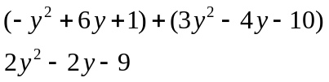

Subtraction
Example
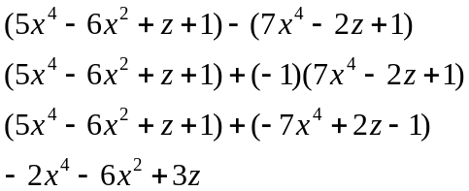

Multiplication
Example
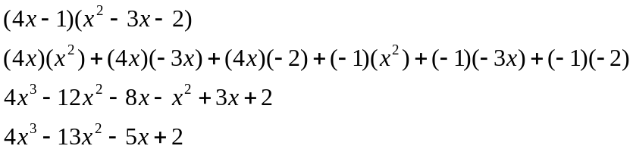

Example
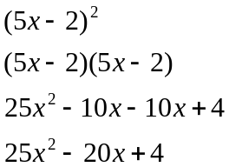

Division
Example
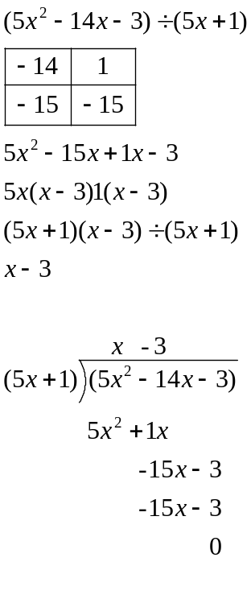

Example
